Lab 8
EIGRP
Objective:
The purpose of this lab is for the student to understand, create and implement EIGRP. Students will also utilize IOS commands to explore and configure EIGRP on network routers and switches.
Diagram:
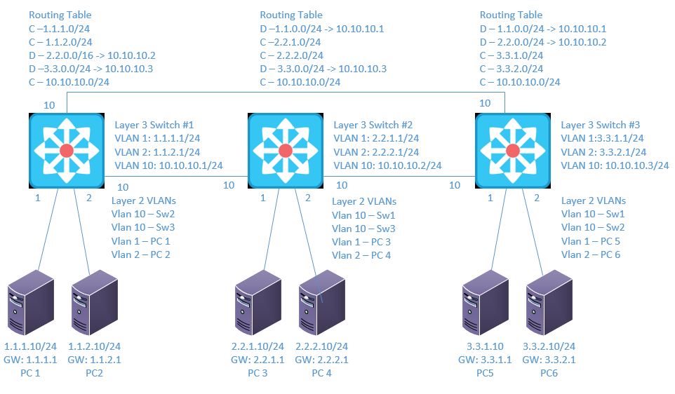
Components:
18 – PC’s with an Ethernet NIC
3 – Layer 3 Switches

Procedure:
- Connect all PC’s together and put their static IP addresses, subnet masks and gateways on them. Test connectivity by pinging each machine within the network.

- Label the Layer 3 switches VLAN IP addresses below
Layer 3 Switch (1)
VLAN | IP
1 | 1.1.1.1/24
2 | 1.1.2.1/24
10 | 10.10.10.1/24

Layer 3 Switch (2)
VLAN | IP
1 | 2.2.1.1/24
2 | 2.2.2.1/24
10 | 10.10.10.2/24

Layer 3 Switch (3)

VLAN | IP
1 | 3.3.1.1/24
2 | 3.3.2.1/24
10 | 10.10.10.3/24

- Label the routing tables for the Layer 3 switch and routers below.
L3Sw1 | L3Sw2 | L3Sw3
C – 1.1.1.0/24 | C – 2.2.1.0/24 | C – 3.3.1.0/24
C – 1.1.2.0/24 | C – 2.2.2.0/24 | C – 3.3.2.0/24
D – 2.2.0.0/16->10.10.10.2 | D – 1.1.0.0/16->10.10.10.1 | D – 2.2.0.0/16->10.10.10.2
D – 3.3.0.0/16->10.10.10.3 | D – 3.3.0.0/16->10.10.10.3 | D – 1.1.0.0/16->10.10.10.1
C – 10.10.10.0/24 | C – 10.10.10.0/24 | C – 10.10.10.0/24

- Label the switches ports and what vlans they are in below.
L3Sw1 | L3Sw2 | L3Sw3
Fa0/1 – VLAN 1 | Fa0/1 – VLAN 1 | Fa0/1 – VLAN 1
Fa0/2 – VLAN 2 | Fa0/2 – VLAN 2 | Fa0/2 – VLAN 2
Fa0/23 – VLAN 10 | Fa0/23 – VLAN 10 | Fa0/23 – VLAN 10
Fa0/24 – VLAN 10 | Fa0/24 – VLAN 10 | Fa0/24 – VLAN 10

- Place the switch ports into the proper vlans. Configure all of the switches vlan IP addresses.

- Enable routing on the Layer 3 switches

- On switch 1 enable router EIGRP as follows:
  - Make the AS number 1
    - What command did you enter
router eigrp 1
  - Turn off auto summary
    - What command did you enter
No auto-summary
  - Add the connected networks to EIGRP
    - What commands did you enter
Network 1.1.1.0 0.0.0.255
Network 1.1.2.0 0.0.0.255
Network 10.10.10.0 0.0.0.255

- On switch 2 enable router EIGRP as follows:
  - Make the AS number 1
    - What command did you enter
Router eigrp 1
  - Turn off auto summary
    - What command did you enter
    - No auto-summary

  - Add the connected networks to EIGRP
    - What commands did you enter
Network 2.2.1.0 0.0.0.255
Network 2.2.2.0 0.0.0.255
Network 10.10.10.0 0.0.0.255

- On switch 3 enable router EIGRP as follows:
  - Make the AS number 1
    - What command did you enter
Router eigrp 1
  - Turn off auto summary
    - What command did you enter
No auto-summary
  - Add the connected networks to EIGRP
    - What commands did you enter
Network 3.3.1.0 0.0.0.255
Network 3.3.2.0 0.0.0.255
Network 10.10.10.0 0.0.0.255

- Verify the routing table on the Layer 3 switches

- Can the computers ping each other? Yes
  - Why? EIGRP is set up on all of the routers and all of the routes are determined.

- View the EIGRP neighbor table on switch 1
  - What command did you enter? show ip eigrp neighbors
  - How many neighbors are listed? 2

- View the EIGRP topology table on switch 1
  - What command did you enter? show ip eigrp topology

  - How many routes are listed?
7 routes are listed
  - What is the FD of routes in the 2.2.1.0/24 network?
51225600
  - What is the RD of routes in the 2.2.1.0/24 network?
25625600
  - What is the FD of routes in the 3.3.1.0/24 network?
51225600
  - What is the RD of routes in the 3.3.1.0/24 network?
25625600
  - Which is bigger the FD or the RD?
The FD is bigger
  - Why? FD is calculated locally and has to account for the link between the neighbors, but RD is calculated by the neighbor and it does not consider the links between the others.

- On switch 1 turn every interface into a passive interface by default
  - What command did you enter? passive-interface default
  - What happened to Switches 1 EIGRP neighbors? They went down
  - Why? The passive interface stops advertising to its neighbors through all interfaces

- On switch 1 turn vlan 10 into a non passive interface

  - What command did you enter? no passive-interface vlan 10
  - What happened to Switches 1 EIGRP neighbors? They’re back up
  - Why? The advertising has resumed through Vlan 10

- On switch 2 and 3 turn every interface into a passive interface by default and turn vlan 10 into a non passive interface

  - Did you observe the same results as switch 1? Yes.

- On switch 1 add authentication to vlan 10 with a key chain of eigrpkeys a key of 1 and a string of netcom
  - What commands did you enter?
Key chain eigrpkeys
Key 1
Key-string netcom
Interface vlan 10
Ip authentication mode eigrp 1 md5
Ip authentication key-chain eigrp 1 eigrpkeys
  - What happened to Switches 1 EIGRP neighbors?
They went down
  - Why?
Authentication is only set up on switch 1, so the communication can’t go through.

- On switch 2 and switch 3 add authentication to vlan 10 with a key chain of eigrpkeys a key of 1 and a string of Netcom

- On switch 1 add a route summary for 1.1.0.0/16
  - What commands did you enter?
Int vlan 10
Ip summary-address eigrp 1 1.1.0.0 255.255.0.0

- View the routing tables on switch 2 and 3 for the 1.1.X.0 networks
  - How many are there? 1
  - Did the table change? Yes
  - Why? Because we summarized the 1.1.1.0 and the 1.1.2.0 networks into one /16.

- On switch 2 add a route summary for 2.2.0.0/16
  - What command did you enter?
Int vlan 10
Ip summary-address eigrp 1 2.2.0.0 255.255.0.0

- On switch 3 add a route summary for 3.3.0.0/16
  - What command did you enter?
Int vlan 10
Ip summary-address eigrp 1 3.3.0.0 255.255.0.0

- View the routing tables on all the switches
  - How many are there? 1 summary network for each
  - Did the table change? Yes
  - Why? Because we summarized the networks into /16s and so they showed up.
  - Does this feature work like OSPF?
Pretty similarly, yes

- Draw the lab diagram below (PC’s, router and switch connections) Label the IP addresses, subnet masks, and gateways used by each device. Label the routing tables next to the switch and router and the switches vlan IP addresses and port vlan information.
